
Help your child with Maths at Home Learning maths at home can be fun and part of everyday life! Here are some simple ideas to help your child enjoy maths at home.
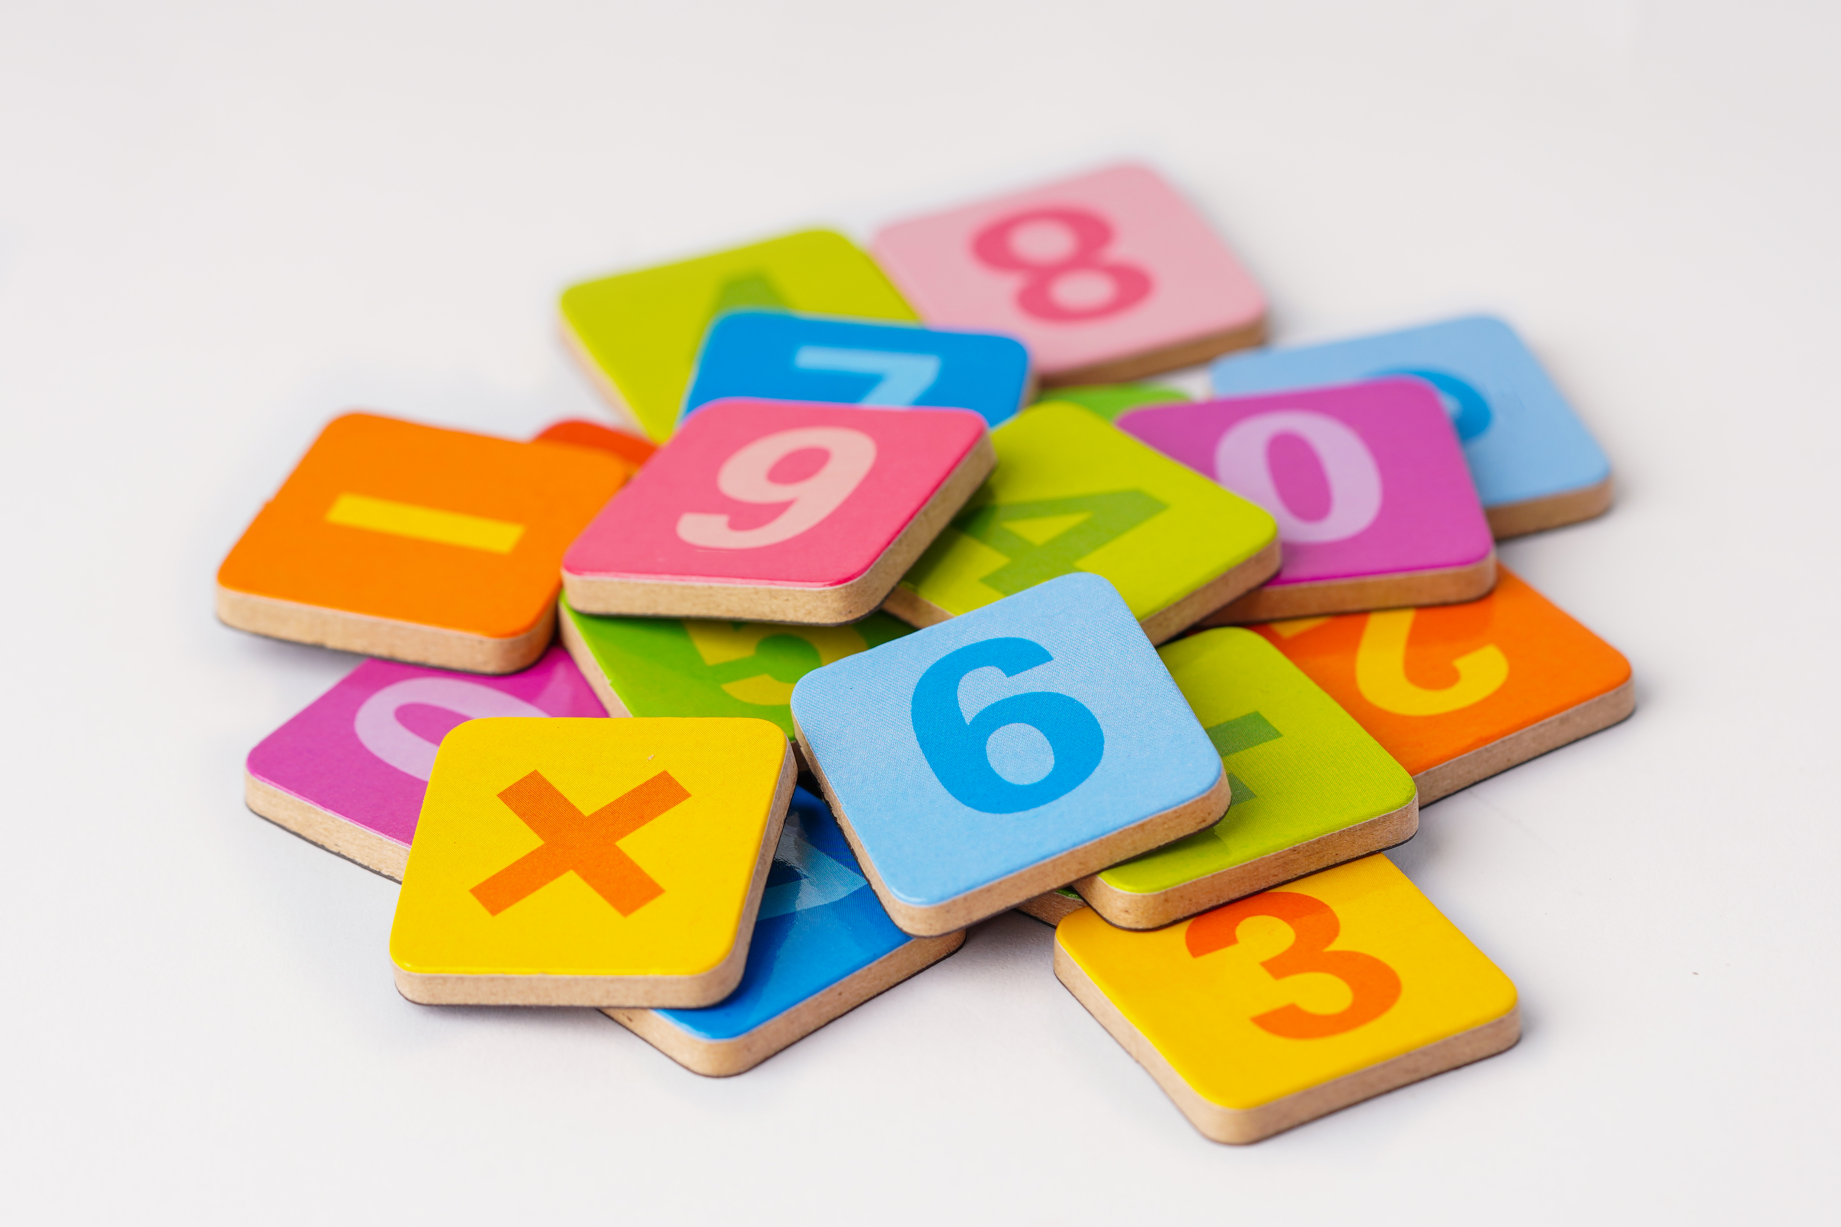
Build Number Sense
• Count everything – steps, toys, fruit, cars you pass.
• Count forwards and backwards from different numbers.
• Compare groups – which has more or fewer?
• Spot numbers on clocks, doors, and signs.
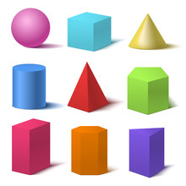
Explore Shapes and Measures
• Find shapes around the home and outside.
• Bake or cook together – measure ingredients and talk about full or empty.
• Compare objects – which is longer, heavier, or holds more?
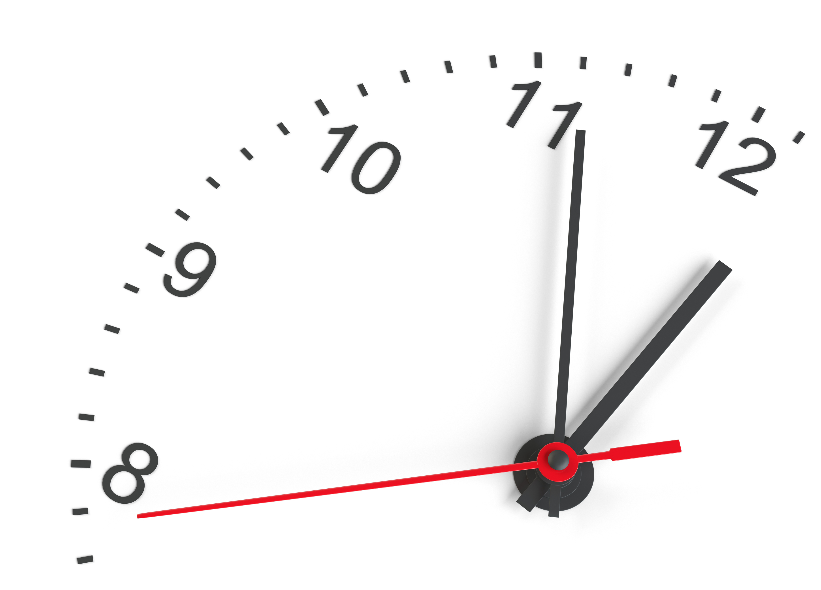
Understanding Time and Money
• Talk about the time of day – morning, afternoon, bedtime.
• Use a clock to notice the hour hand and minute hand.
• Play shop with coins – add small amounts and give change.
• Talk about days of the week and routines.
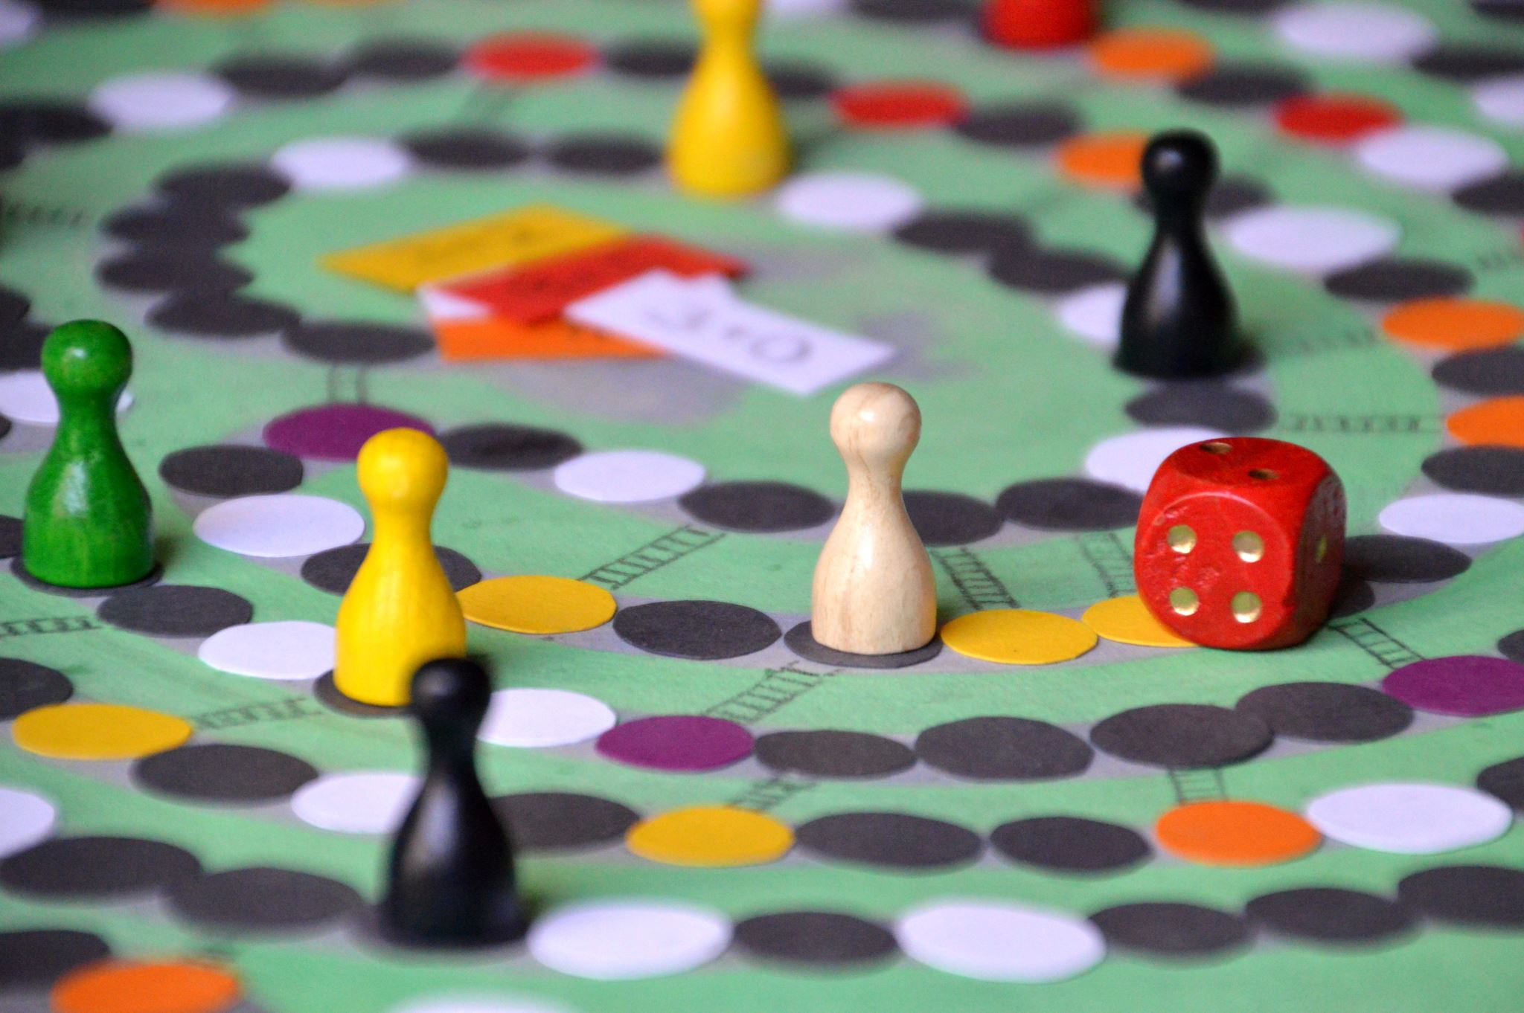
Fun Maths Games
• Play board games that use dice – great for counting on!
• Dominoes – match dots and count totals.


Encouraging Confidence
• Praise effort and persistence, not just answers.
• Talk through problems aloud – show how to fix mistakes.
• Keep maths short, fun, and part of daily routines.


Useful Websites
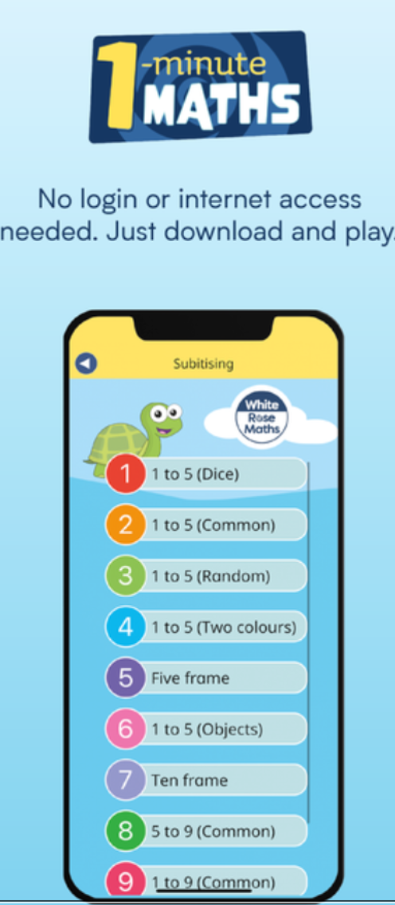
• BBC Bitesize – fun, curriculum-linked activities. Numberblocks on BBC iPlayer
• TopMarks – interactive games for Key Stage 1.
• White Rose Maths – One minute maths. Simple ideas for home learning.


